# CSC242: ASSIGNMENT 2

Implement the functions below in the template file **[lastname]PA2.**py which can be found on [the D2L site](http://d2l.depaul.edu/) in the dropbox for the assignment.  Be sure to remove the ‘pass’ statements and change the docstrings as instructed. Submit the .py file to the submission box.

Functions submitted with syntax errors which prevent starting the function will receive 0 points. Runtime errors will result in 50% off the points for the function.

For this assignment, you are to design and develop code that defines and implements a Building object, Residence object, House object, and Commercial object.

|  |  |  |  |  |
| --- | --- | --- | --- | --- |
| **PROPERTIES** | **BUILDING** | **RESIDENCE** | **COMMERCIAL** | **HOUSE** |
| Property id/name |  | X |  | x |
| Square footage | X | X | X | X |
| Year Built | X | X | X | x |
| Number of rooms |  | X |  | x |
| Basement? |  | X |  | X |
| Lot Dimensions(wxd) |  | X |  | X |
| Number of floors |  |  | X |  |
| Zoning |  |  | X |  |
| Value ($) |  | X | X | X |
| **METHODS** | **BUILDING** | **RESIDENCE** | **COMMERCIAL** | **HOUSE** |
| Constructor | X | X | X | X |
| Set property value |  | x | x | x |
| Show property value |  | X | X | X |
| Show square footage of lot |  | X |  | x |
| Show zoning |  |  | X |  |
| String representation of object (for users) *see below | X | X | X | X |
| “Official” String representation of object (for programmers) *see below | X | X | X | X |

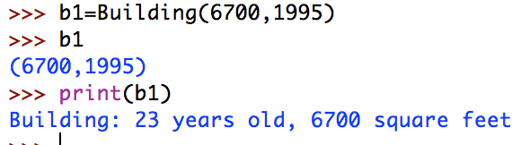

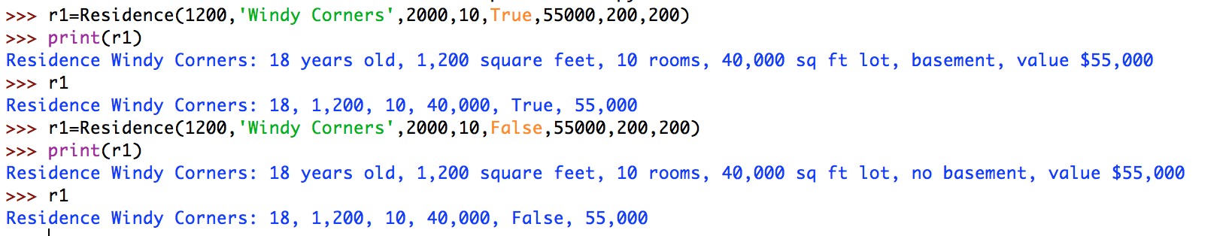

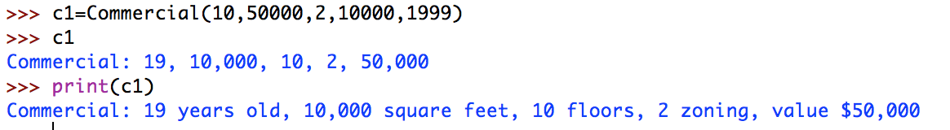

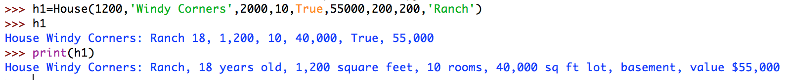

## Submitting the assignment

For full credit, check for the following before submitting:

1. your program file must be named [yourlastname]asg1.py
2. your name must be at the top of the file
3. all ‘pass’ statements must have been removed
4. your program must not have any syntax errors or runtime errors to get full credit
5. the functions must have identical names to those described in this assignment

**You must submit the .py file to the dropbox by the due date.**

Up to the due date, you can submit as many versions of your solution as you would like. The last file submitted is the one graded. The final file should contain solutions for all of the problems in the assignment. There will be no grading across submissions. Submissions must make the deadline or a zero is given for the assignment.

## Grading

You will only receive points if the code you submit runs without syntax errors.